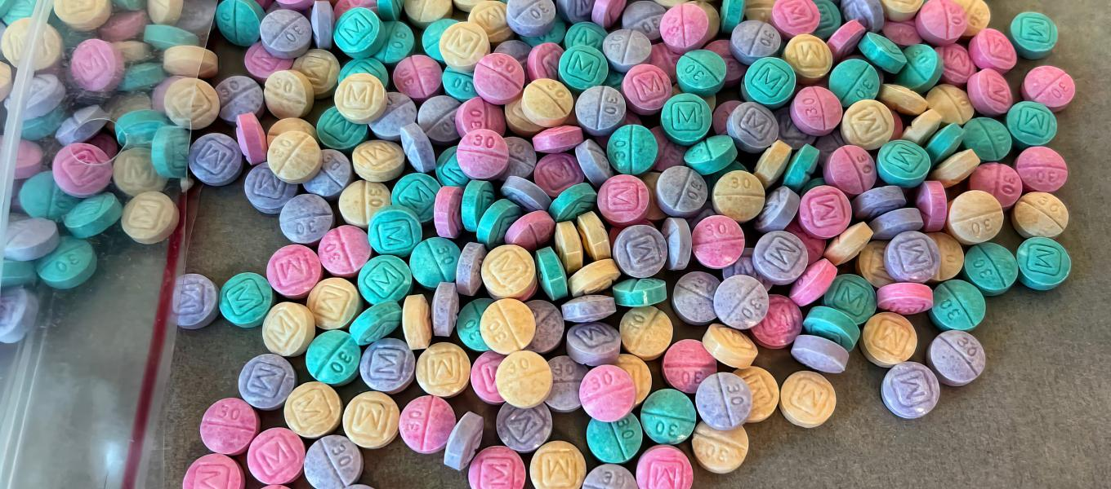
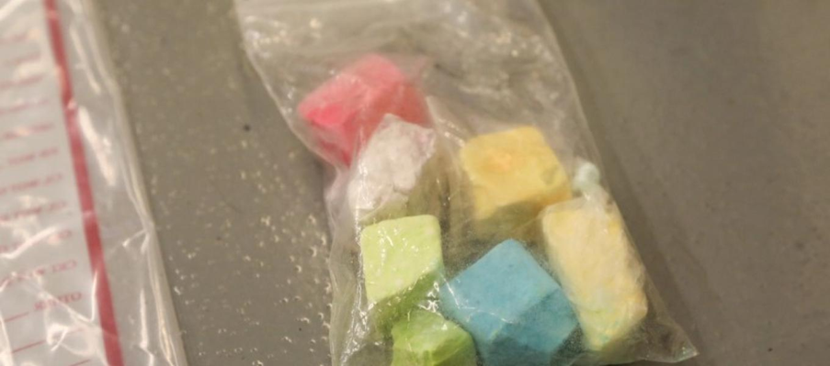
Rainbow Fentanyl

The DEA has issued a public warning educating the community about rainbow fentanyl. These particular pills are targeted to youth and young adults by its colorful candy-like appearance making them look harmless. Rainbow Fentanyl resembles playground chalk before it is pressed into pills and has been found in 18 states including West Virginia and New York and are sold as low as $17 (Hawaii) per pill making them affordable. In August of 2022 47,000 pills were confiscated at the Arizona border as well as 186,000 “Perc 30’s” or “Blues”, another popular synthetic opioid found in our county.

The trend, as reported by users, is to crush the pills, smoke it off of a piece of aluminum foil, with the theory that it is “safer” than snorting. When burned, it often gives off a distinct odor of burned rubber. While we have not seen Rainbow Fentynal yet, Perc 30’s or Blues are popular among adolescents and young adults in Fairfax County and the surrounding areas. Fentanyl is also found in counterfeit prescription pills, cocaine, Xanax, and other licit and illicit drugs.

The Medical Examiner from the Virginia Department of Health recently released its 1st quarter data for 2022 stating 483 people have died from fatal fentanyl overdoses in the state. For Fairfax County data and additional information on youth substance use, please see the Fairfax County Youth Substance Trends webinar linked below.

Substance Abuse Prevention Specialists (SAPS) provide Tier 1 support throughout FCPS. Each high school pyramid is assigned a SAPS who conducts brief interventions, psychoeducation, and presentations to students, staff, families, and community members. Topics of discussion include alcohol, tobacco and other drugs (ATOD) as well as current trends on substances. For general questions about the FCPS Substance Abuse Prevention Program, please contact the Office of Student Safety & Wellness at: (571) 423-4270.

Sources & Resources: For further Information & support:
DEA Rainbow Fentanyl Press Release Michael McNulty
DEA Fentanyl Gallery mpmcnulty@fcps.edu
Narcan Training (English & Spanish) Substance Abuse Prevention Specialist
Fairfax County Youth Substance Use Trends

