Natural High

The Problem:
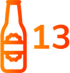
Studies have shown that 13 is the average age of first-time drug and alcohol use.

9 out of 10 addictions start in the teen years.
90% of Americans with a substance use disorder began using substances before the age of 18.
Natural High is “a drug prevention nonprofit that inspires and empowers youth to find their natural high and develop the skills and courage to live life well.” The Natural High campaign highlights helping children and teens find healthy thrilling activities to fulfill the dopamine (feel good) levels in the brain.

Solutions:
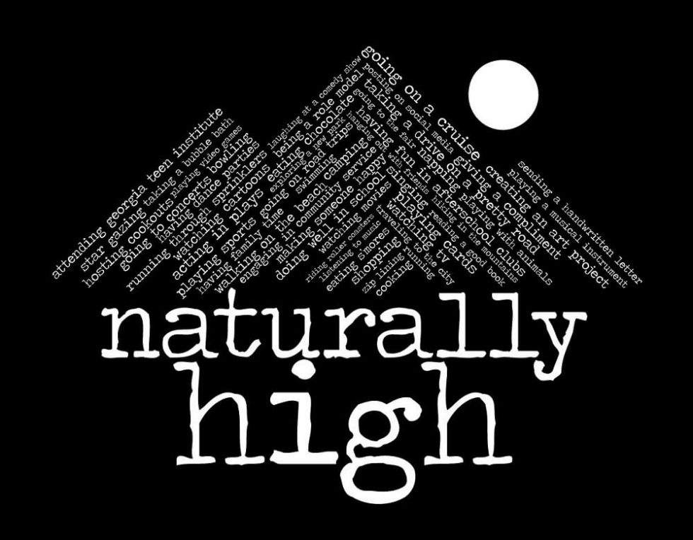

Resources:
- Natural High
- Fentanyl Is Now The Leading Cause of Death For Young People In the US (Video)
- Live Your Life Naturally High
- Knowing The Signs: Substance Abuse & Today’s Use (Video)
- Adolescent Substance Use: America’s #1 Public Health Problem

FCPS video on Alcohol, Tobacco, and Other Drugs: https://dl.ebmcdn.net/fcps/courses/ATODParentPresentationRequired103119b/story_html5.html
For general questions about the FCPS Substance Abuse Prevention Program, please contact the Office of Student Safety & Wellness at: (571) 423-4270.
For further Information & support:
Michael McNulty
Substance Abuse Prevention Specialist
mpmcnulty@fcps.edu

