Modeling Responsible Behavior

Parents and caregivers play an important role in modeling responsible behavior for their children. Young children will grow to become adolescents and then adults who are responsible for their own behavior. These adults have taken information from what they’ve seen in the world and experienced, to make their own life choices. Once your children graduate from high school, 90% of the time you will spend with them has already passed. They may join the workforce, leave for college, and then live on their own, they will no longer spend as much time under your toolage and have less access to your wise counsel.

Begin to think about what happens in that 90% of time you have with them. What do you want them to emulate? What conversations do you want to have? What hopes and dreams would you like to share with them? What will be your lasting legacy? Parents have a huge impact on whether or not their children use alcohol and drugs. Maintaining a strong, open, and non-judgmental relationship with them will create a safe space for potentially uncomfortable conversations. Children make better decisions when they have positive relationships with their parents. Although many have an Airpod in their ears 70% of the time, they’re listening and watching more than you think. Speak honestly and directly while setting firm boundaries. Make sure your actions match your words.

For general questions about the FCPS Substance Abuse Prevention Program, please contact the Office of Student Safety & Wellness at: (571) 423-4270.
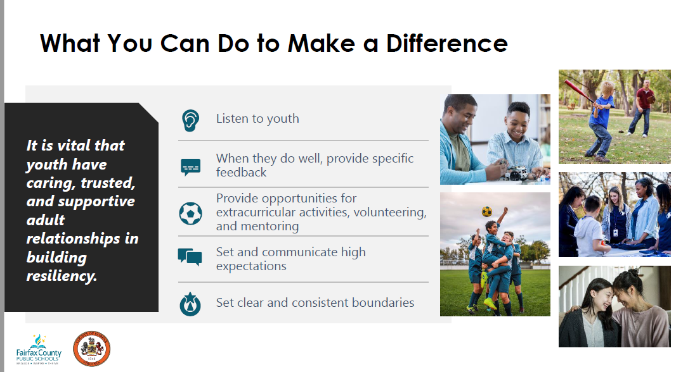

Sources & Resources
- Why You Should Talk to Your Child About Alcohol & Drugs
- Fairfax County Youth Survey
- Talk They Hear You
- FCPS Substance Abuse Prevention Program

For further Information & support:
Michael McNulty
Substance Abuse Prevention Specialist
mpmcnulty@fcps.edu

