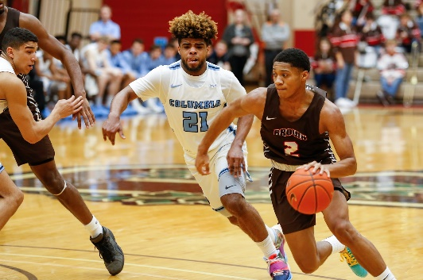
March Madness

What is binge drinking?

Binge drinking refers to consuming a large amount of alcohol quickly. It’s a practice that pushes up blood alcohol levels fast. For men, binge drinking is typically five or more drinks in two hours. Women reach a blood alcohol level of .08 or more with four drinks in two hours or less.

Why is binge drinking risky?

Teenagers who binge-drink even once are at higher risk of: getting alcohol poisoning. not being able to look after themselves while drunk. taking dangerous risks and having accidents – for example, being killed on the road while walking home drunk.

What can you do to help stop?

Stop Teenage Drinking: 10 ways to keep your kid safe
- Talk to your kids, not at them.
- Education is key.
- Help teens understand the risk
- Get involved
- Be a positive influence
- Eliminate Temptation
- Be aware of the warning signs
- Establish clear rules
- Teach refusal skills
- Create and commit to a family pledge.

For general questions about the FCPS Substance Abuse Prevention Program, please contact the Office of Student Safety & Wellness at: (571) 423-4270.
For further Information & support:
Michael McNulty
Substance Abuse Prevention Specialist
mpmcnulty@fcps.edu

