Alcohol, Sexual Assault, and Consent

April is Sexual Assault Awareness Month. People ages 12-34 are at the highest risk for rape and sexual assault (RAINN). The majority of sexual assault victims are under the age of 30. One out of every six American women have been the victim/survivor of an attempted or completed sexual assault. One out of every ten males are sexual assault victims (RAINN).

Alcohol can play a part in sexual assault. Alcohol reduces inhibitions and alcohol consumption by perpetrators and victims tends to co-occur, meaning, when one of them is drinking, the other one is generally drinking as well. At least one half of all violent crimes involve the use of alcohol. Although a person’s alcohol consumption is one risk factor for sexual assault, they are in no way responsible for what happened to them.

Sexual violence of any type or unwanted sexual contact, is not okay. This includes words and actions of a sexual nature against a person’s will and without their consent.

For general questions about the FCPS Substance Abuse Prevention Program, please contact the Office of Student Safety & Wellness at: (571) 423-4270. Be sure to follow us on Twitter at @FCPSSAPS.

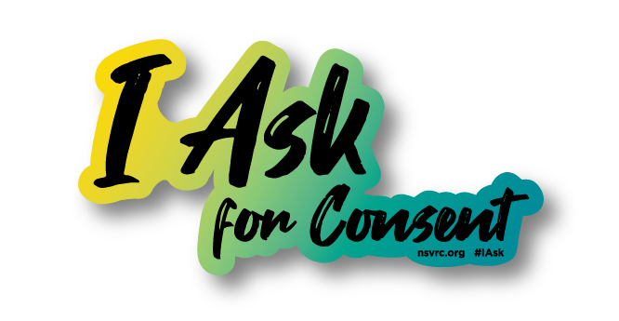
Sources & Resources:
- Alcohol and Sexual Assault
- Sexual Violence Statistics
- Adverse Childhood Experiences
- FCPS Title IX
- Make a Difference: Talk to Your Child About Alcohol

For further Information & support:
Michael McNulty
Substance Abuse Prevention Specialist
mpmcnulty@fcps.edu

Drug Additives to Be Aware of: Xylazine“Tranq”
In our continuing efforts to educate the community, we have been tracking a new trend in the region known as Xylazine or Tranq. Tranq, a non-opioid tranquilizer, is often mixed with other drugs giving the user a fentanyl-like high for an extended period of time. Considering the rise in opioid-related overdoses, it is important to know about various additives such as fentanyl and tranq that can be mixed in, unbeknownst to the user. Xylazine is an animal tranquilizer which is not approved by the FDA for human consumption; it affects the central nervous system by suppressing breathing and slowing down vital functions in the body. Tranq has recently been detected in several fatal overdoses related to cocaine, heroin, and fentanyl in unsuspecting users. Narcan/Naloxone, an opioid overdose reversal medication, will not reverse the overdose in a person who has taken Tranq thus resulting in potential death. Continued use has resulted in lesions, ulcers, and other health related issues resulting in loss of limbs from untreated abscesses.
While alarming, education is key to keep our communities safe. Here is some recent data showing the trend in our region. Xylazine was present in 19% of drug overdoses in Maryland in 2020 alone; with trends increasing in Pennsylvania by 26% and in Connecticut by 10%. In areas of higher populations Xylazine has been present in 1 of every 5 deaths that have been reported. According to the Centers for Disease Control, Xylazine was present in 64.3 % of deaths when it was detected. 38 states including the District of Columbia have seen a rise in “Tranq” in and around their communities.
For general questions about the FCPS Substance Abuse Prevention Program, please contact the Office of Student Safety & Wellness at: (571) 423-4270. Be sure to follow us on Twitter at @FCPSSAPS.
Sources & Resources:
- NIH: Xylazine
- DEA: Xylazine
- DEA: Fentanyl Mixed with Xylazine
- CDC: Xylazine
- Overdoses in Philadelphia
- FCPS Webinar: Everything You Need To Know About Opioids

For further Information & support:
Michael McNulty
Substance Abuse Prevention Specialist
mpmcnulty@fcps.edu

